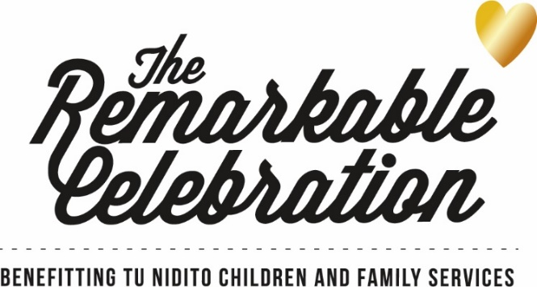

2023 Remarkable Mom Nomination Form
At Tu Nidito, our mission is to create a community of acceptance and understanding regarding children in grief. It is our vision that no child grieves alone. Each spring Tu Nidito honors mothers in our community who speak to the heart of our mission. These mothers also reflect the beauty and diversity of our Southern Arizona community. Whether it’s overcoming their own obstacles in the face of a serious medical diagnosis or death or making a difference in the lives of our community’s children, Tu Nidito's Remarkable Moms are a role model not just for her own children but for our community as well.
Please consider the strong, kind, loving and remarkable moms in your life and nominate them to be recognized and celebrated at Tu Nidito’s Remarkable Celebration event taking place Saturday, May 6, 2023.

Some nominators like to have friends and family submit additional letters of support for their nominee. This is encouraged! The more we know about each Remarkable Mom Honoree, the better. Please direct additional letters of support to Debbie (address and contact information at the end of this form).

The deadline to submit a nomination is Friday, October 21, 2022. We encourage you to include as much information about your nominee as possible. Remarkable Moms honorees will be selected and notified in December 2022/January 2023. Thank you!

Nominee:______________________________________________________________________

Nominee’s Phone Number: _______________________________________________________

Nominee’s Email Address: ________________________________________________________

Nominee’s Employer:____________________________________________________________

Nominee’s Ethnicity:____________________________________________________________

Why is this woman a Remarkable Mom?
__________________________________________________________________________________________________________________________________________________________________________________________________________________________________________
____________________________________________________________________________________________________________________________________________________________
____________________________________________________________________________________________________________________________________________________________
____________________________________________________________________________________________________________________________________________________________

Does this mother’s life resemble the mission of Tu Nidito in regards to grief, either personally or professionally? How is this mother a role model in our community and/or making a difference in the lives of our community’s children? Please explain.
__________________________________________________________________________________________________________________________________________________________________________________________________________________________________________
____________________________________________________________________________________________________________________________________________________________
____________________________________________________________________________________________________________________________________________________________
____________________________________________________________________________________________________________________________________________________________
____________________________________________________________________________________________________________________________________________________________
____________________________________________________________________________________________________________________________________________________________

Children’s Names/Ages/Employer (if applicable)
____________________________________________________________________________________________________________________________________________________________
____________________________________________________________________________________________________________________________________________________________

Spouse’s Name and Employer (if applicable):
______________________________________________________________________________

Other Relevant Information:
______________________________________________________________________________
______________________________________________________________________________
______________________________________________________________________________
______________________________________________________________________________

Nominated by:
______________________________________________________________________________

Your Email:
____________________________________

Your Phone:
_________________________________
All nominations must be received by Friday, October 21, 2022

Completed forms may be mailed to:
Tu Nidito
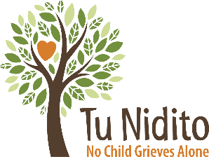
Attn: Debbie Rich, Director of Development
3922 North Mountain Avenue
Tucson, Arizona 85719

Forms may be submitted via email to Debbie Rich at debbie@tunidito.org
Questions? Contact Tu Nidito (520) 322-9155

